**HTML Text Formatting**

**What is Text Formatting:**

HTML contains several tags for defining text with a special meaning.

There are many tags in HTML to define text with a special meaning.

**Example:**

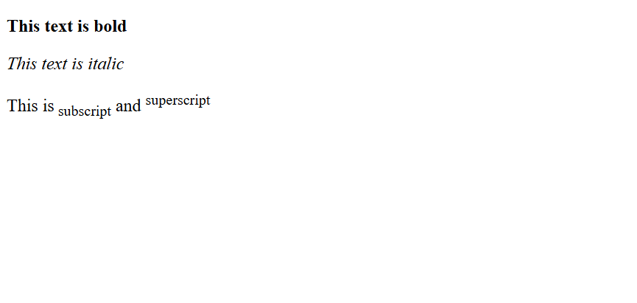

**HTML Formatting Tags:**

Formatting elements were designed to display special types of text:

* <b> - Bold text
* <strong> - Important text
* <i> - Italic text
* <em> - Emphasized text
* <mark> - Marked text
* <small> - Smaller text
* <del> - Deleted text
* <ins> - Inserted text
* <sub> - Subscript text
* <sup> - Superscript text

**The HTML <b> and <strong> Tags:**

The HTML **<b>** element defines bold text, without any extra importance.

**Code:**

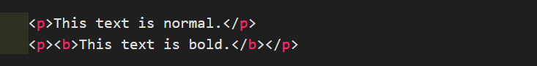

**Output:**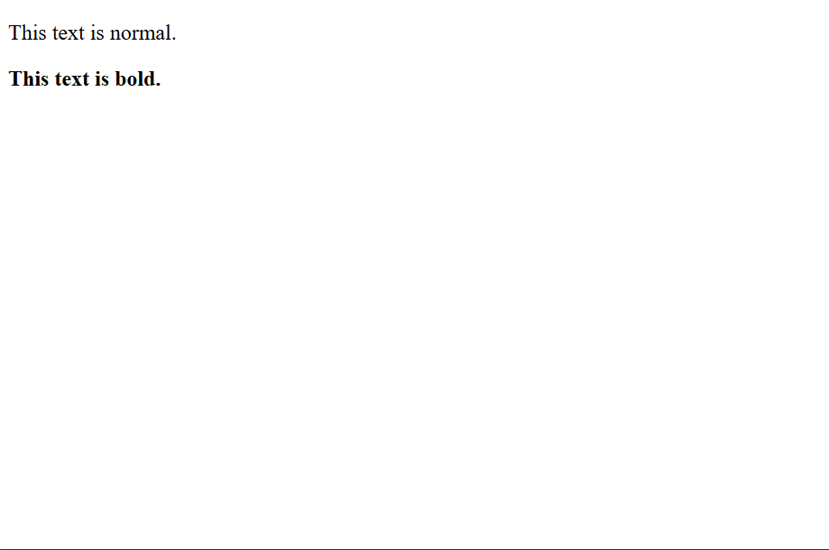

The HTML **<strong>** element defines text with strong importance. The content inside is typically displayed in bold.

**Code:**

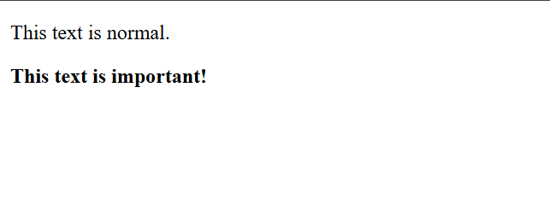

**Output:**

**The HTML <i> and <em> Tags:**

The HTML **<i>** element defines a part of text in an alternate voice or mood. The content inside is typically displayed in italic.

**Tip:** The **<i>** tag is often used to indicate a technical term, a phrase from another language, a thought, a ship name, etc.

**Code:**



**Output:**

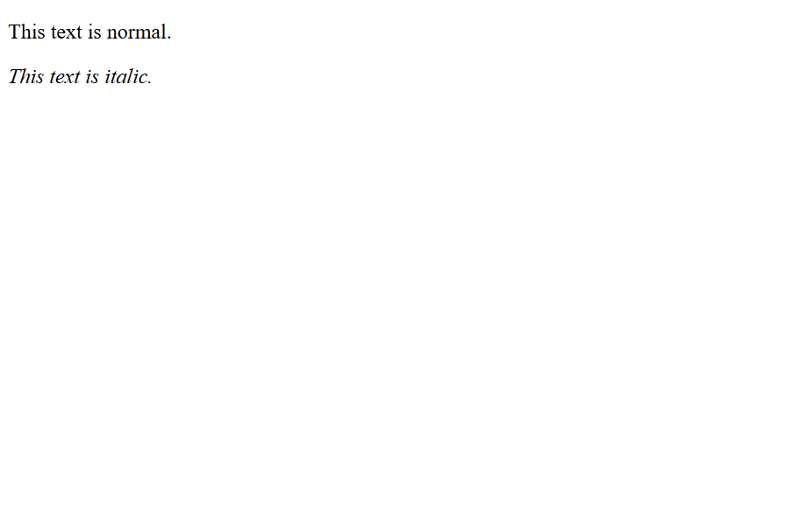

The HTML **<em>** element defines emphasized text. The content inside is typically displayed in italic.

**Tip:** A screen reader will pronounce the words in **<em>** with an emphasis, using verbal stress.

**Code:**



**Output:**

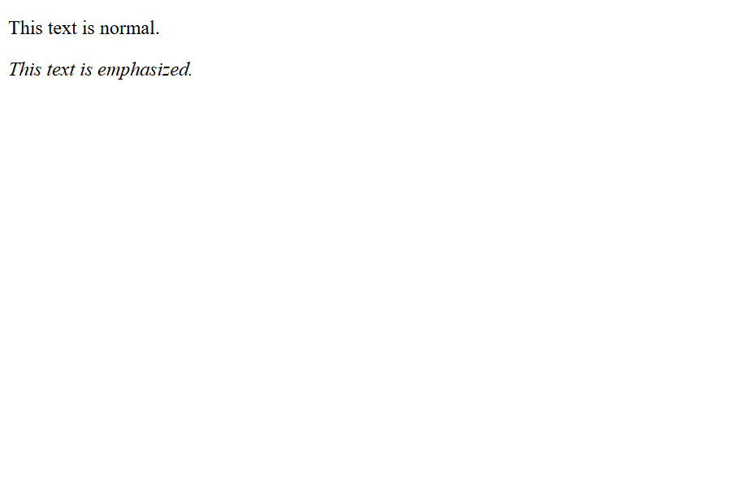

**The HTML <small> Tag:**

The HTML <small> element defines smaller text:

**Code:**



**Output:**

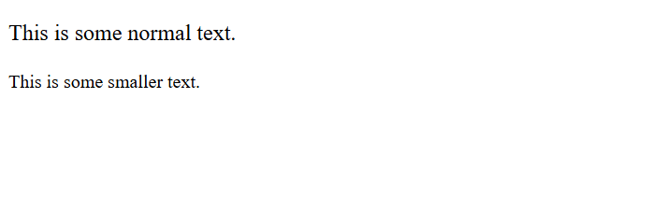

**The HTML <mark> Tag:**

The HTML <mark> element defines text that should be marked or highlighted:

**Code:**



**Output:**

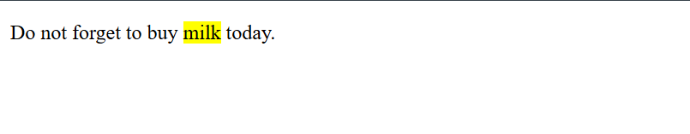

**The HTML <del> Tag:**

The HTML <del> element defines text that has been deleted from a document. Browsers will usually strike a line through deleted text:

**Code:**



**Output:**

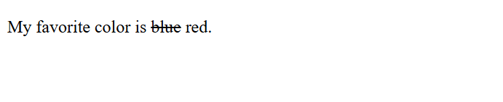

**The HTML <ins> Tag:**

The HTML <ins> element defines a text that has been inserted into a document. Browsers will usually underline inserted text.

**Code:**

**See the difference between delete and insert tag:**



**Output:**



**The HTML <sub> Tag:**

The HTML <sub> element defines subscript text.

Subscript text appears half a character below the normal line, and is sometimes rendered in a smaller font.

Subscript text can be used for chemical formulas, like H2:

**Code:**



**Output:**

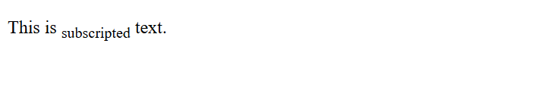

**The HTML <sup> Tag:**

The HTML <sup> element defines superscript text. Superscript text appears half a character above the normal line, and is sometimes rendered in a smaller font. Superscript text can be used for footnotes, like WWW [1]:

**Code:**



**Output:**

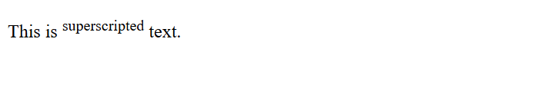

**Summary:**

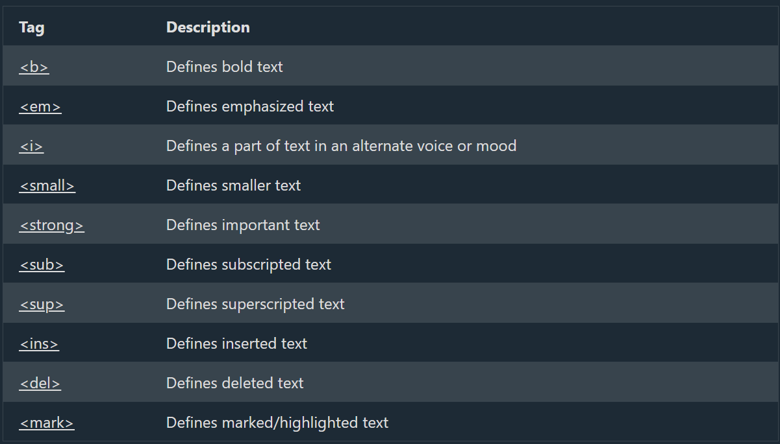

**Reference:**

<https://www.w3schools.com/tags/tag_b.asp>

<https://www.w3schools.com/tags/tag_em.asp>

<https://www.w3schools.com/tags/tag_i.asp>

<https://www.w3schools.com/tags/tag_small.asp>

<https://www.w3schools.com/tags/tag_strong.asp>

<https://www.w3schools.com/tags/tag_sub.asp>

<https://www.w3schools.com/tags/tag_sup.asp>

<https://www.w3schools.com/tags/tag_ins.asp>

<https://www.w3schools.com/tags/tag_del.asp>

<https://www.w3schools.com/tags/tag_mark.asp>